**Introduction to project**

* The Cosmetic Shop Management System is a software solution designed to streamline and optimize the operations of cosmetic shops or beauty stores. In today's competitive market, efficient management of inventory, sales, customer relationships, and appointments is essential for the success of a cosmetic business. The Cosmetic Shop Management System offers a comprehensive set of tools and features to meet these demands and enhance overall business efficiency.
* With its user-friendly interface and customizable options, the Cosmetic Shop Management System can be easily adapted to suit the requirements of different-sized cosmetic shops, whether it's a small boutique or a chain of stores. Additionally, the system ensures data security and access control, safeguarding sensitive information such as customer data and financial records.
* I have completed my project on cosmetic shop. There is need for efficient management of a network-base system for handling customer orders.
* In this project Customer can view all category and then view product after login or signing and they can order that products and also can payment and they can get product at their home.
* Admin can show customer details and order details and maintain their order and delivers it.
* I finally decide to develop this project and hence planned to develop this system using html, CSS, bootstrap, JavaScript, php on front end and MySQL as the back end.

**Project Profile**

* **Developed At** – Darshan University
* **Developed By** - Ishita Savera
* **Operating System** - Microsoft Windows XP, 95, 98, 2000, Professional,7,8.
* **Web Server** - XAMPP
* **Web Browser** - Internet Explorer 6.0, Mozilla Firefox, Google Chrome.
* **Editor** – Visual studio, Notepad++, Subline
* **Guided By** – Prof.Nidhi Chiroda

**System Requirement**

It specified minimum requirement of any project It contain hardware and software requirements of project. The detail about minimum system requirement in this project as given bellow.

**Platform (Software): ~**

Windows XP

Windows 98

Windows any other platform

1. **Front End and Back End Tools (Software): ~**

• Front End Tools:

HTML

PHP

• Back End:

MySQL

1. **Hardware Requirement Specification: ~**

256 MB RAM.

HDD with 40GB or Higher capacity

VGA Monitor (Resolution 800 X 600 pixel or 1024 X 768 pixels)

Compatible printer for Report printing

**Project Details**

* **Admin**
* Customer: In this section admin can see all details of customer and delete from this side.
* Category: admin can show all category list.
* Add Category: Admin can add category.
* Delete Category: Admin can delete category.
* Edit Category: Admin can Edit Product.
* Product: admin can show all Product list.
* Add Product: Admin can add Product.
* Delete Product: Admin can delete Product.
* Edit Product: Admin can Edit Product.
* Order: Admin can show all order list.
* Delete Order: Admin can delete all order.
* Payment: Admin can Show Payment list
* Delete Payment: Admin can delete payment.
* Contact Details: Admin can show contact details.
* Delete Contact: Admin can delete contact details.
* **User**
* Sign in: In this section user can register.
* Login: In this section user can login.
* Home Page: User can visit this website.
* About Us: User can get details of cosmetic shop.
* Category: User can show all category.
* Product: User can show all product and their details.
* Order Product: User can order their product.
* Payment: User can payment in this section.
* Contact Us: User can contact with cosmetic shop.

**Limitation**

**Payment Method Issues:**

Ensure that the payment information you entered is accurate. Double- check the credit card number, expiration date, CVV, and billing address.

**Inventory Limitations:**

The products you're trying to purchase may have limited availability. If there's insufficient stock for one or more items, the platform may prevent you from buying them together.

**Website or Platform Restrictions:**

Some online platforms or websites may have restrictions on the number of items you can purchase in a single transaction. Check the platform's terms of service or product purchase policies for any limitations.

**Future Scope**

The future scope of cosmetic shop management systems is vast, with several potential areas for development and innovation. Some key areas of future exploration and enhancement include:

**Integration of Artificial Intelligence (AI) and Machine Learning (ML):**

AI and ML technologies can be leveraged to analyze customer data, predict trends, and optimize inventory management. For example, ML algorithms can forecast demand for specific cosmetics based on various factors such as seasonality, consumer preferences, and social media trends.

AI-powered chatbots can enhance customer service by providing instant responses to inquiries, assisting with product recommendations, and facilitating seamless transactions.

**Enhanced Personalization:**

Future cosmetic shop management systems can focus on delivering more personalized shopping experiences. This could include advanced CRM functionalities that enable targeted marketing campaigns based on individual customer preferences, purchase history, and demographics.

Personalized product recommendations, virtual try-on features, and interactive digital displays can further enhance the shopping experience, driving customer engagement and loyalty.

**Omni-channel Integration:**

With the growing popularity of online shopping, cosmetic shop management systems need to seamlessly integrate with various sales channels, including brick-and-mortar stores, e-commerce platforms, mobile apps, and social media channels.

Implementing omni-channel capabilities allows customers to browse products, make purchases, and access loyalty rewards across multiple touchpoints, creating a cohesive shopping experience regardless of the channel they choose.

**Enhanced Analytics and Business Intelligence:**

Future systems can focus on providing more sophisticated analytics and business intelligence tools to help cosmetic retailers gain deeper insights into customer behavior, market trends, and competitor analysis.

Advanced analytics capabilities such as predictive analytics, sentiment analysis, and geospatial analysis can empower retailers to make data-driven decisions and stay ahead of the competition.

**Sustainability and Ethical Sourcing:**

As consumers become increasingly conscious of sustainability and ethical sourcing practices, future cosmetic shop management systems may incorporate features to track and communicate the sustainability credentials of products.

This could involve integrating supply chain transparency tools to trace the origins of ingredients, as well as providing customers with information on eco-friendly packaging, cruelty-free certifications, and carbon footprint reduction initiatives.

**Enhanced Security and Data Privacy:**

With the rising threat of cyberattacks and data breaches, future systems will need to prioritize robust security measures to protect sensitive customer and business data.

This may involve implementing advanced encryption techniques, multi-factor authentication, and regular security audits to ensure compliance with data protection regulations such as GDPR and CCPA.

Overall, the future scope of cosmetic shop management systems lies in leveraging emerging technologies, enhancing customer experiences, improving operational efficiency, and addressing evolving industry trends such as sustainability and digital transformation. By staying abreast of these developments and embracing innovation, cosmetic retailers can position themselves for success in an increasingly competitive market landscape.

**Feasibility Study**

A feasibility study of a cosmetic management system involves evaluating the practicality, viability, and potential success of implementing such a system within a cosmetic retail business. Here's how you can conduct a feasibility study:

**Technical Feasibility:**

Assess the technical requirements of implementing a cosmetic management system, including hardware, software, and network infrastructure.

Evaluate whether the existing infrastructure can support the system or if upgrades or additional resources are necessary.

Determine the compatibility of the management system with other existing software and systems used within the business.

**Operational Feasibility:**

Analyze how the cosmetic management system will fit into the current business operations and workflows.

Identify potential changes or adaptations required in business processes to integrate the system effectively.

Assess the willingness and ability of employees to adapt to and utilize the new system, considering factors such as training needs and resistance to change.

**Economic Feasibility:**

Estimate the costs associated with acquiring, implementing, and maintaining the cosmetic management system, including software licensing fees, hardware costs, training expenses, and ongoing support fees.

Compare the projected costs with the expected benefits and potential cost savings derived from implementing the system.

Conduct a cost-benefit analysis to determine the financial viability of the investment over the long term.

**Legal and Regulatory Feasibility:**

Ensure that the cosmetic management system complies with relevant laws, regulations, and industry standards related to data protection, consumer privacy, and electronic transactions.

Identify any legal or regulatory hurdles that may need to be addressed before implementing the system, such as obtaining necessary permits or certifications.

**Market Feasibility:**

Evaluate the market demand for a cosmetic management system within the target industry and geographical region.

Analyze the competitive landscape to identify existing solutions and potential competitors offering similar products or services.

Assess the potential market share and revenue opportunities for the cosmetic management system based on customer needs and preferences.

**Schedule Feasibility:**

Develop a timeline for the implementation of the cosmetic management system, considering factors such as project scope, resource availability, and potential disruptions to business operations.

Identify critical milestones and dependencies to ensure that the project stays on track and meets the planned timeline.

Assess the feasibility of meeting the desired implementation timeline based on available resources and constraints.

**Cost Estimation**

Cost estimation is the process of approximating the expenses associated with a project, product, or service. It involves analyzing various factors and variables to determine the overall cost involved. Here's a general overview of the steps involved in cost estimation:

**Identify Project Scope:**

Clearly define the scope of the project, including deliverables, requirements, and objectives. Understanding the scope helps in determining the extent of work and resources required.

**Breakdown of Work:**

Break down the project into smaller tasks or work packages. This breakdown helps in identifying the specific components or activities that contribute to the overall cost.

**Resource Identification**:

Identify the resources needed to complete each task or work package. This includes labor, materials, equipment, facilities, and any other resources required for project execution.

**Resource Costing:**

Determine the cost associated with each resource. This may involve obtaining quotes from suppliers, referencing historical data, or using industry-standard cost databases.

**Labor Cost Estimation:**

Estimate the labor hours required for each task or activity. Use labor rates to calculate the labor cost based on the estimated hours.

**Material Cost Estimation:**

Estimate the quantity and cost of materials required for the project. Consider factors such as material unit cost, waste, transportation, and storage costs.

**Equipment Cost Estimation:**

Determine the cost of any equipment or machinery needed for the project. This may include purchase or rental costs, maintenance expenses, and depreciation.

**Overhead and Contingency:**

Factor in overhead costs such as utilities, administrative expenses, and indirect labor. Additionally, include a contingency allowance to account for unforeseen events or changes in project scope.

**Risk Assessment:**

Identify potential risks that could impact project cost and schedule. Evaluate the likelihood and potential impact of each risk, and incorporate risk mitigation strategies into the cost estimation.

**Calculation and Analysis:**

Calculate the total cost by summing up the individual cost components for each task or work package. Analyze the cost estimate to ensure accuracy, completeness, and consistency.

**Documentation and Presentation:**

Document the cost estimation process, assumptions, and rationale behind the cost estimates. Present the cost estimate in a clear and understandable format, highlighting key findings and assumptions.

**Review and Validation:**

Review the cost estimate with relevant stakeholders, such as project sponsors, management, and subject matter experts. Validate the estimate against project requirements, constraints, and benchmarks.

By following these steps, project managers and stakeholders can develop accurate and reliable cost estimates to support decision-making, budgeting, and project planning. Regular updates and revisions to the cost estimate throughout the project lifecycle help in monitoring project costs and ensuring financial accountability.

**Problems of Existing System**

**Issue no. 1 Transparency, traceability, sustainability**

Three parts of one big issue for the beauty & cosmetics market. With growing public awareness over plastics, animal testing, water pollution, palm oil, and worker exploitation (and that list is not exhaustive), beauty & cosmetic brands are having to provide transparency and in many cases review and adapt their products to remain true to customer’s desires. Consumers want visibility all the way back to origin, they want clearer labelling, and they want assurance that the products they are buying are in line with their ethics.

**Issue no. 2 – Online/Offline**

In recent years there has been a blurring in the way we shop for beauty & cosmetics. Online sales are helping drive the market, with around half of the [**growth coming from online sales**](https://www.forbes.com/sites/richardkestenbaum/2018/09/09/beauty-industry-biggest-trends-skin-care-loreal-shiseido-lauder/). Social media has added benefit and complexity in equal measure, with users sharing their experiences, reviews and advice about products with thousands of others at the click of a button. This can be great for exposure if the review is positive, but if not, product sales can really suffer. However, the store does remain an important element in this market. As much as beauty & cosmetics retailers have invested in their online sites, they just cannot replicate the results of trying cosmetics in the store. Consumers though want choice in how they shop – they may browse online and then come in to the store to test and make a purchase, or some shoppers may look and test products in-store and then make their purchase online.

**Advantages**

**Product Information:**

Online platforms often provide detailed product descriptions, ingredient lists, and customer reviews, helping customers make informed decisions about their purchases.

**Comparison Shopping:**

Consumers can easily compare prices, features, and reviews of different products and brands, enabling them to find the best value for their money.

**Special Discounts and Promotions:**

Online cosmetic shops frequently offer exclusive discounts, promotions, and loyalty programs, allowing customers to save money on their favorite products.

**Implementation Process**

Planning

Maintenance

Testing

Implementation

Design

Analysis

**Diagrams**

**DFD:**

**0 Level DFD:**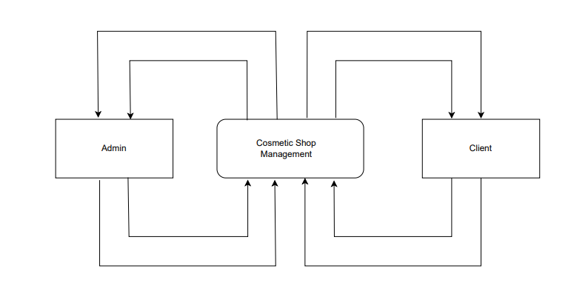

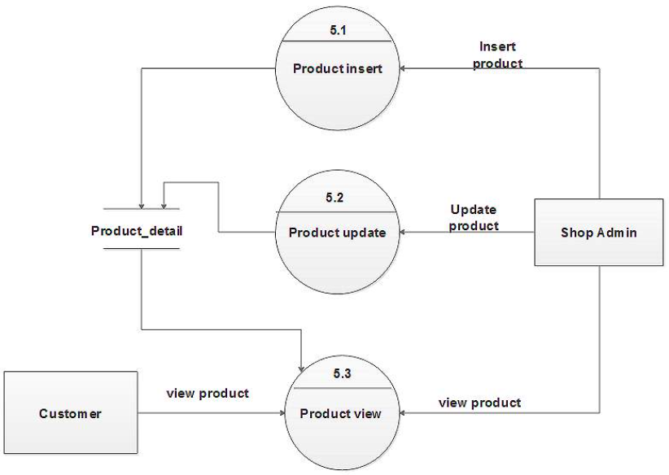**1 Level DFD:**

**Use Case Diagram:**

**1.Customer:**

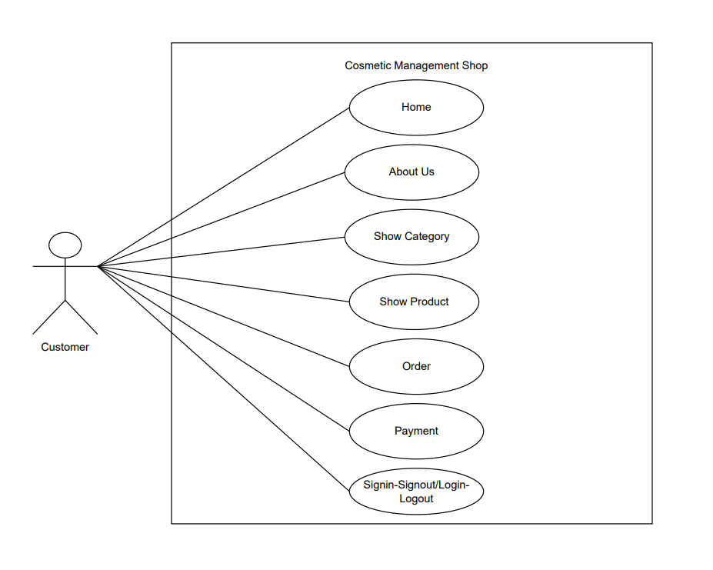

**2.Admin:**

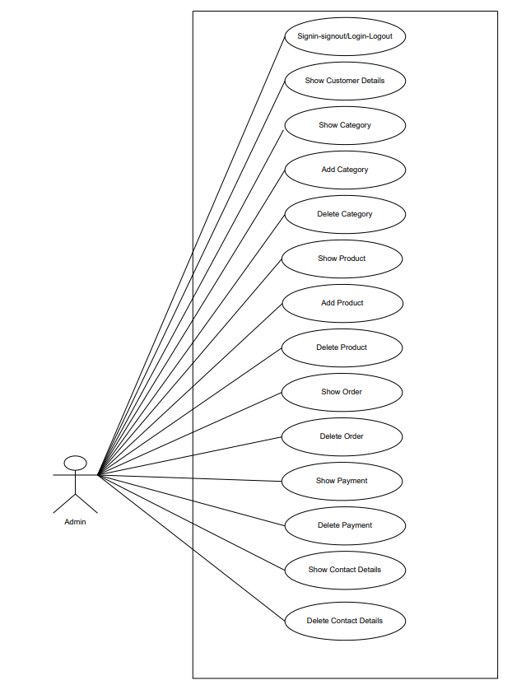

**Class Diagram:**

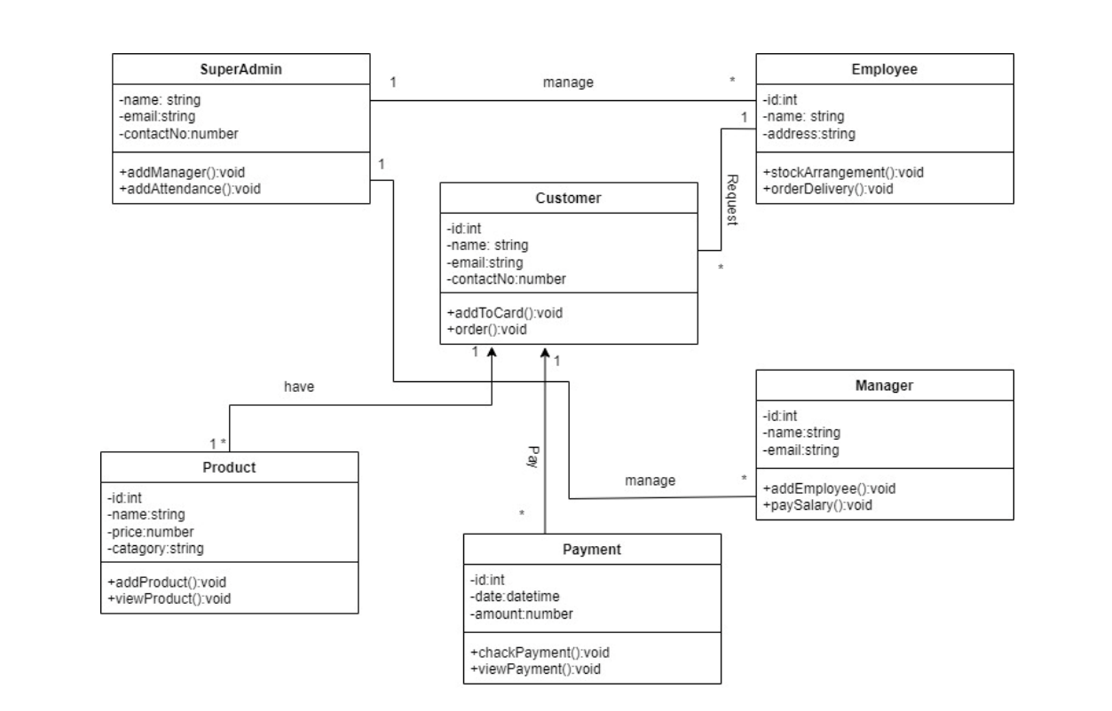

**State Diagram:**

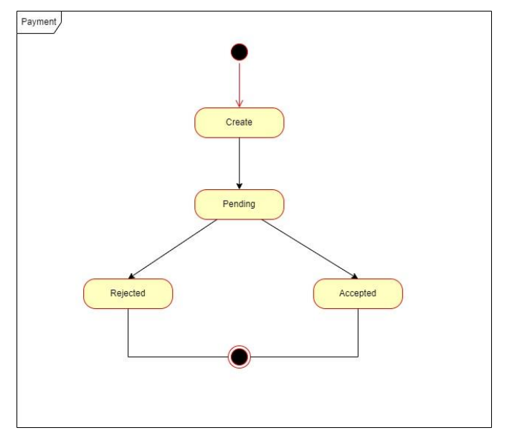

**Swimlane Diagram:**

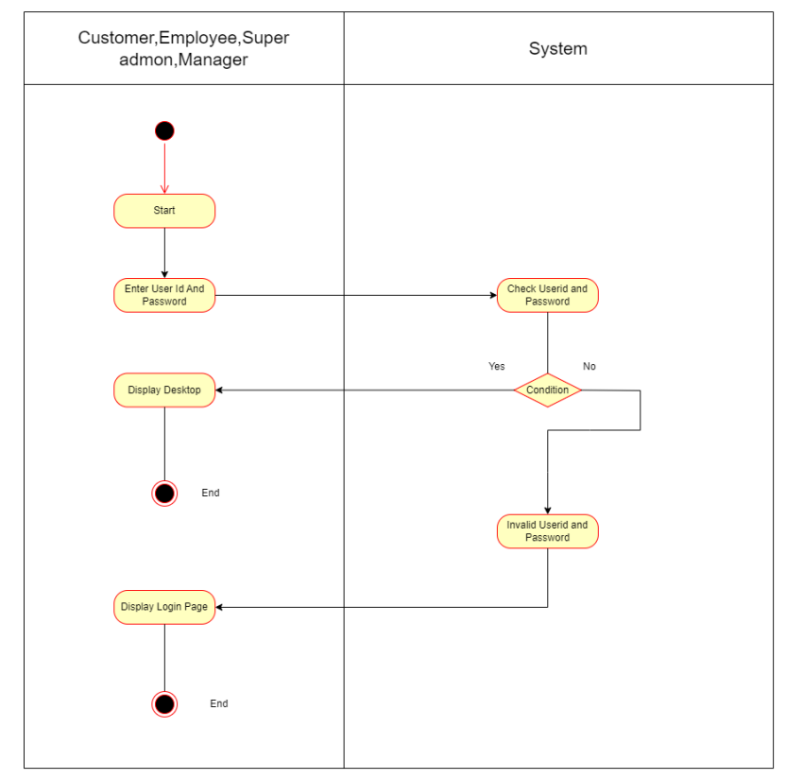

**Activity Diagram:**

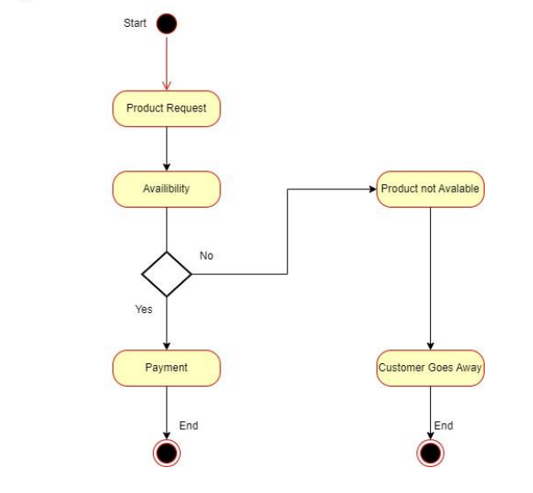**1.Order Activity:**

**2.Product Activity:**

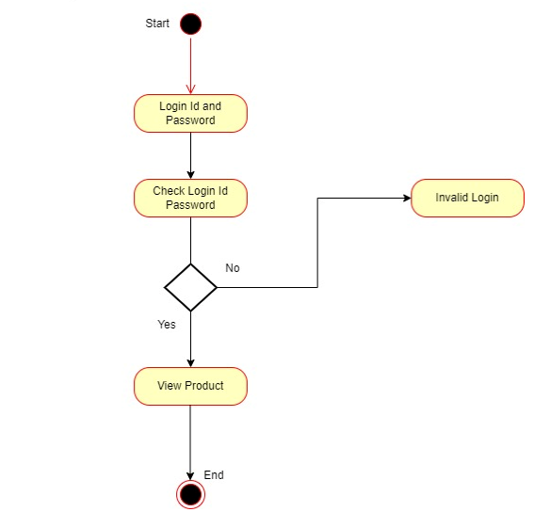

**Sequence Diagram:**

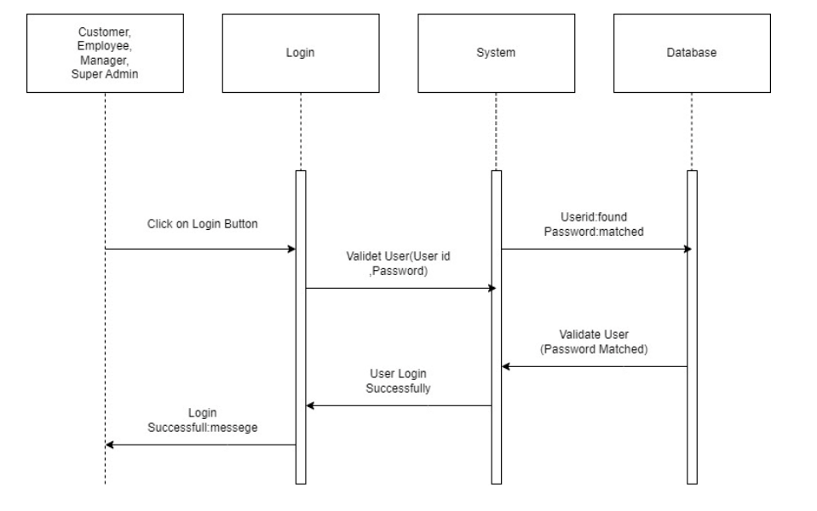

**Data Dictionary**

Data dictionary is the center responsibility of information about system and Organization. Data dictionary contain a list of trim and their meaning for all data items and data storages of the system.

**Show Tables:**

**Register Table:**

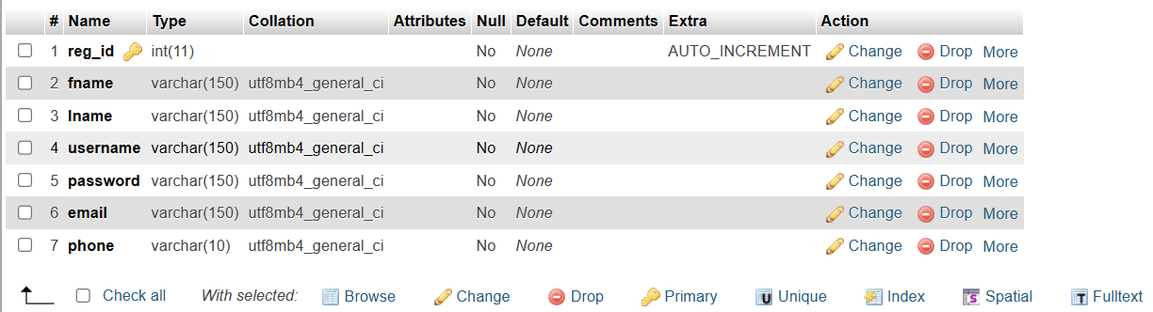

**Category Table:**

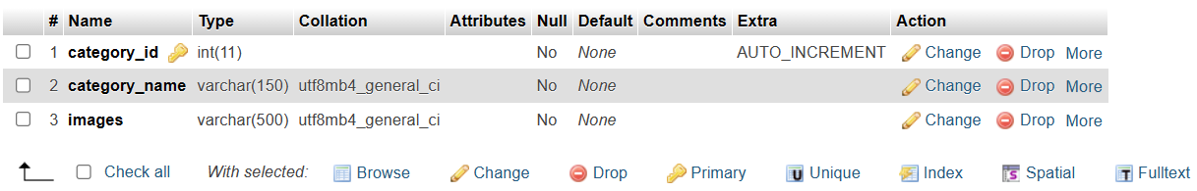

**Product Table:**

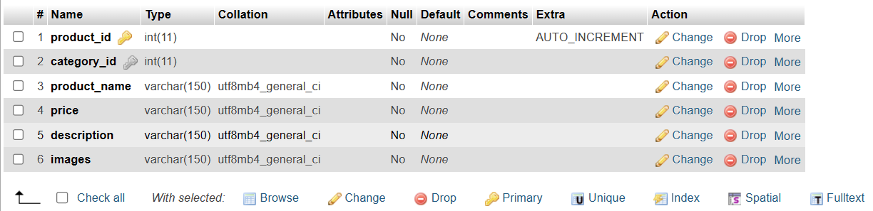

**Order Table:**

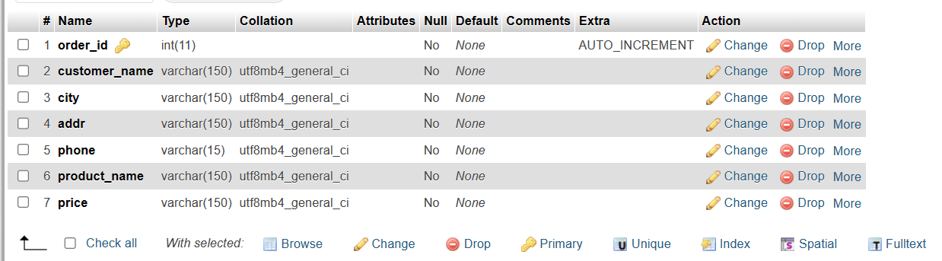

**Payment:**

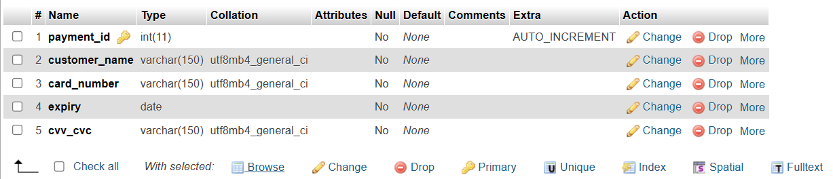

**Contact Table:**

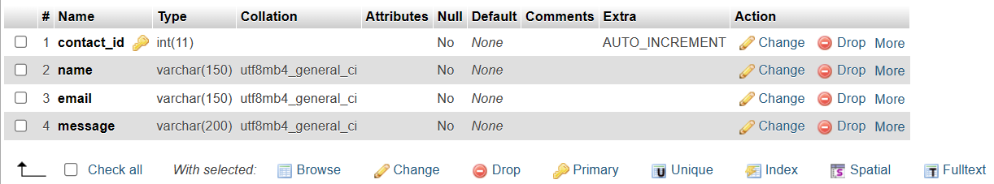

**Client-side Web Pages**

**Home Page:**

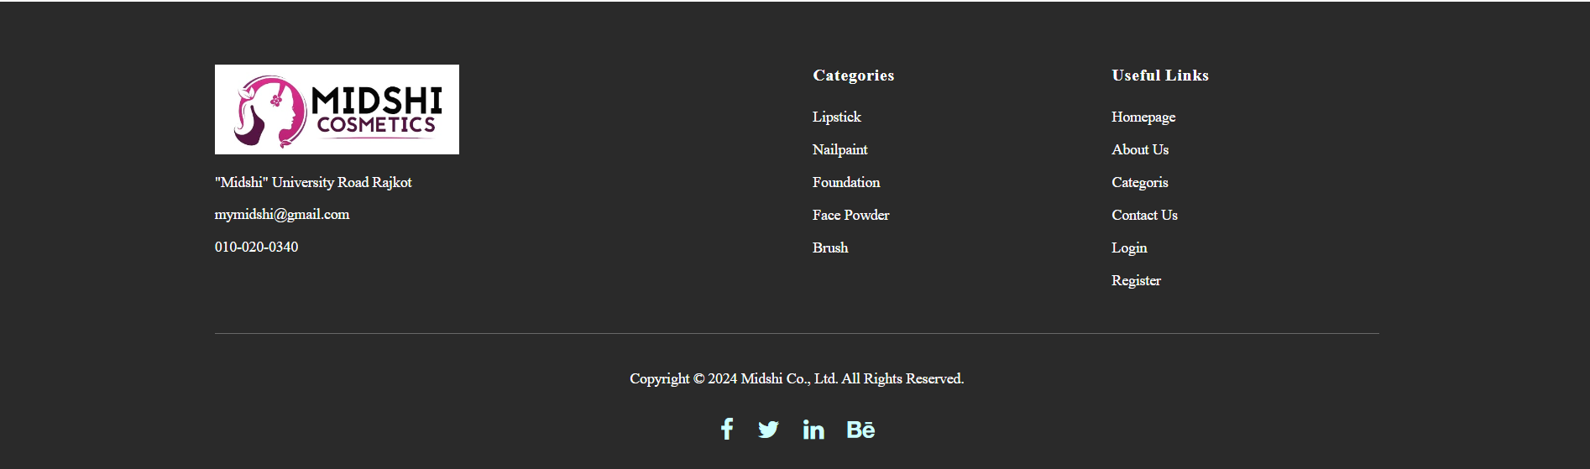

**About Page:**



**Category Page:**

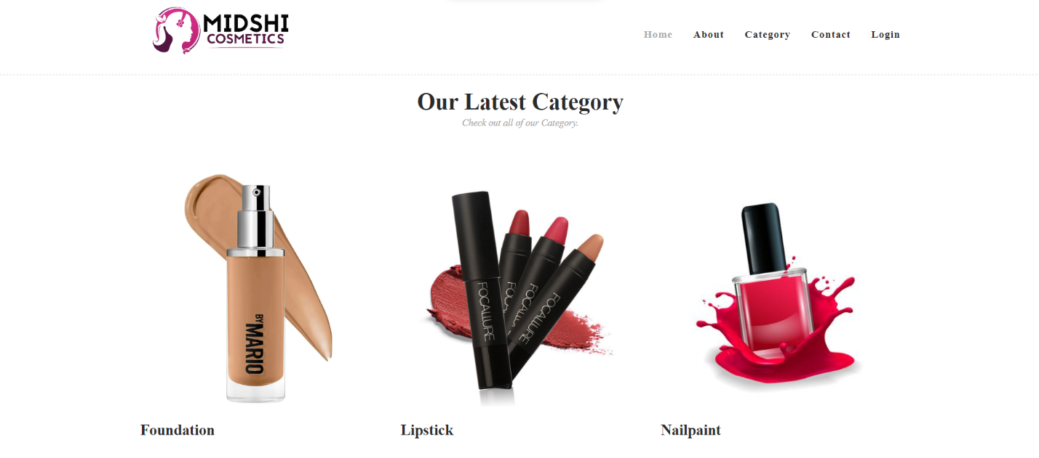

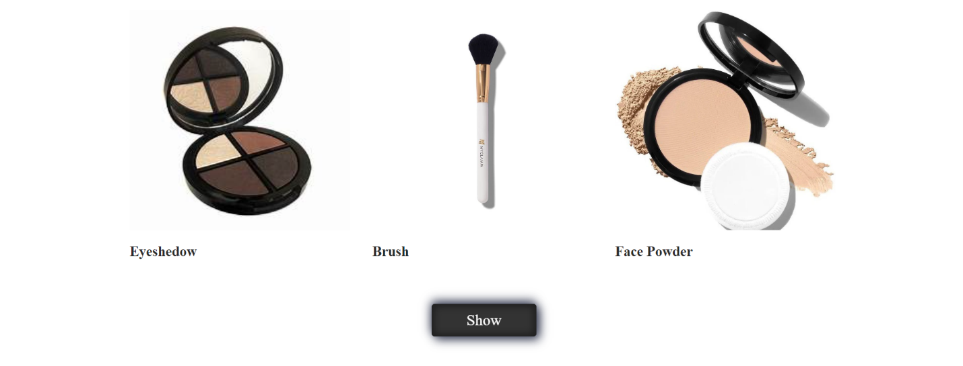

**Product Page:**

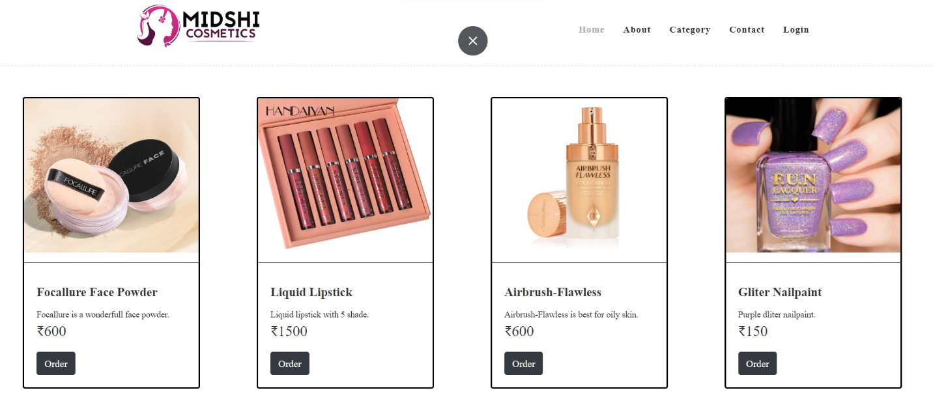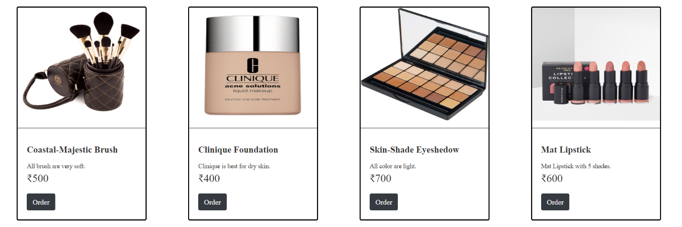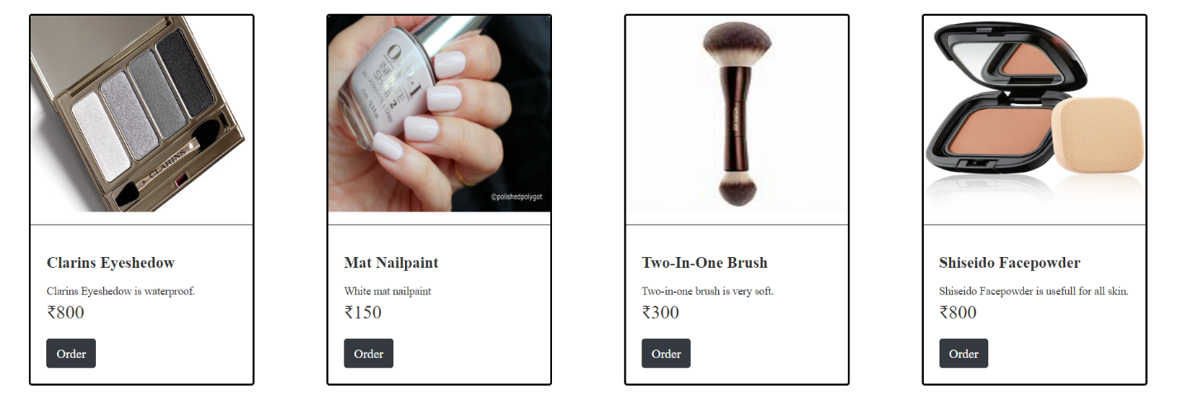

**Order Page:**

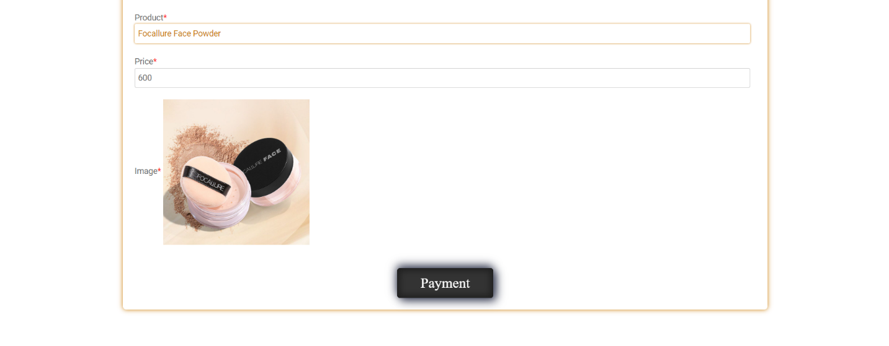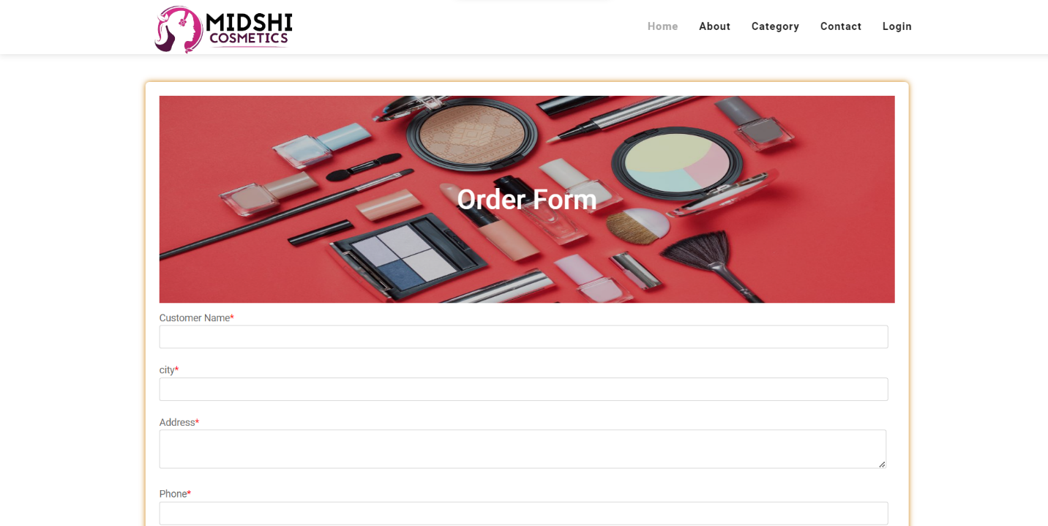

**Payment Page:**



**Contact US Page:**

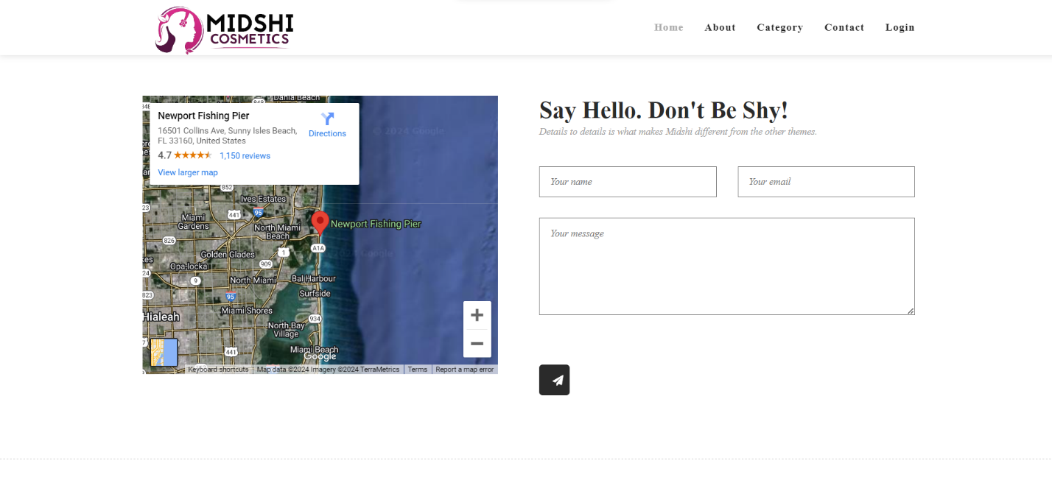

**Registration Page:**

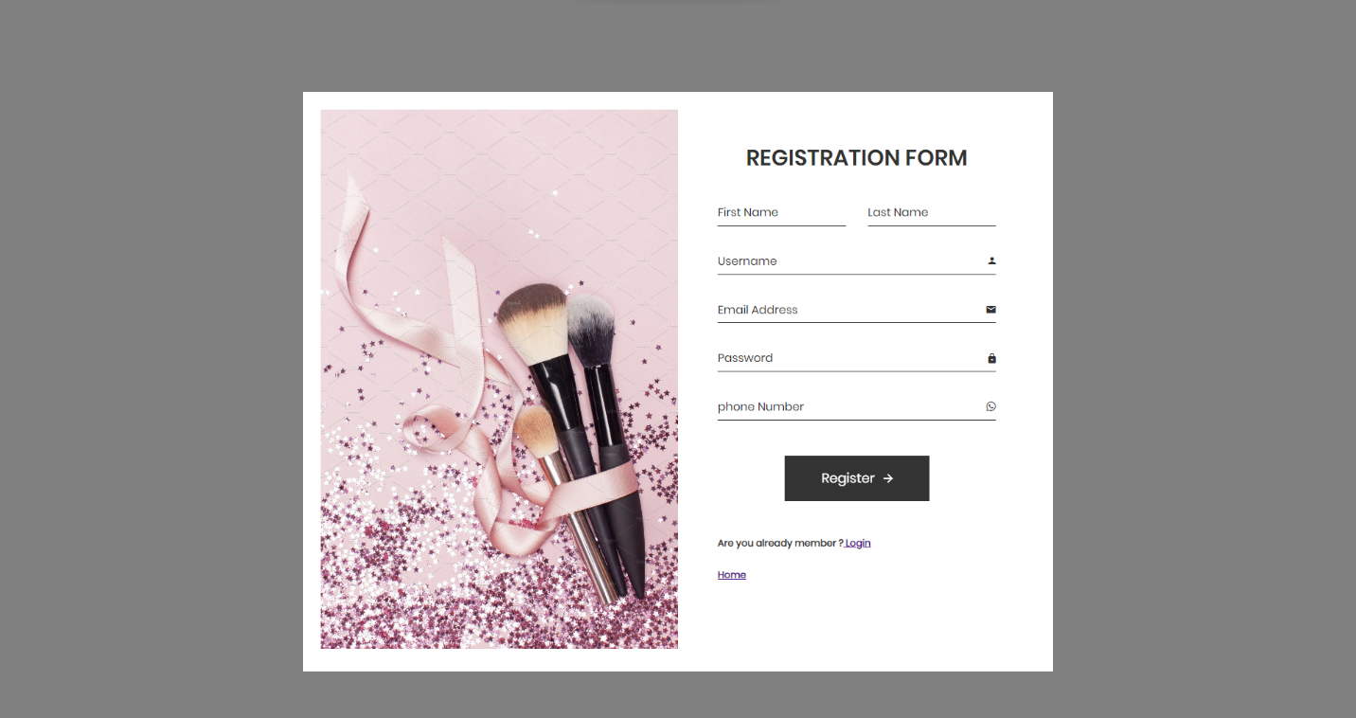

**Login Page:**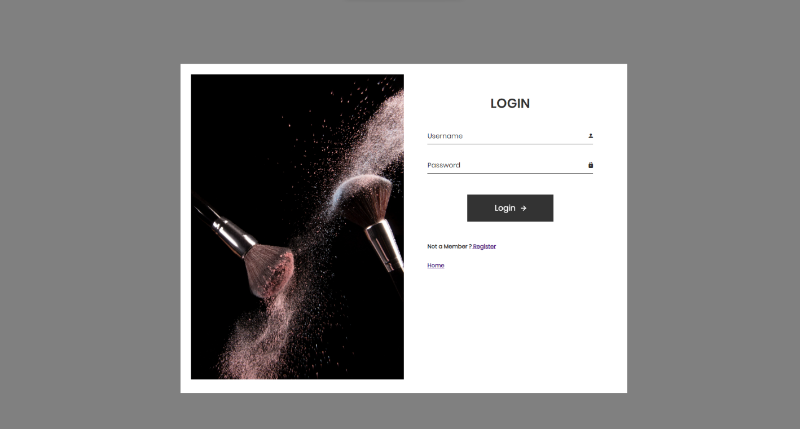

**Admin-side Web Pages**

**Login Page:**

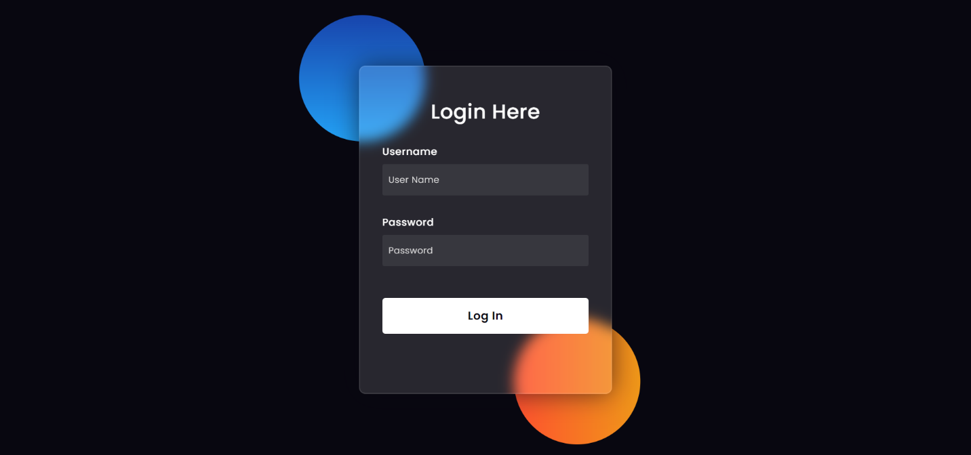

**Dashboard Page:**

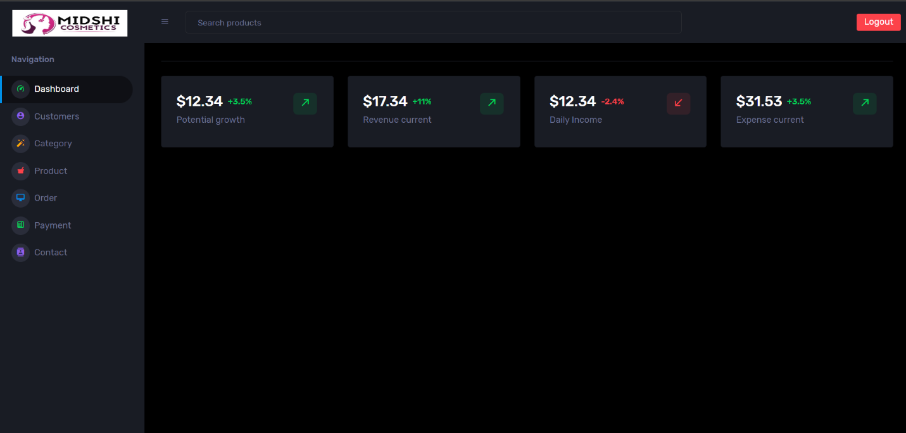

**Customer Details Page:**

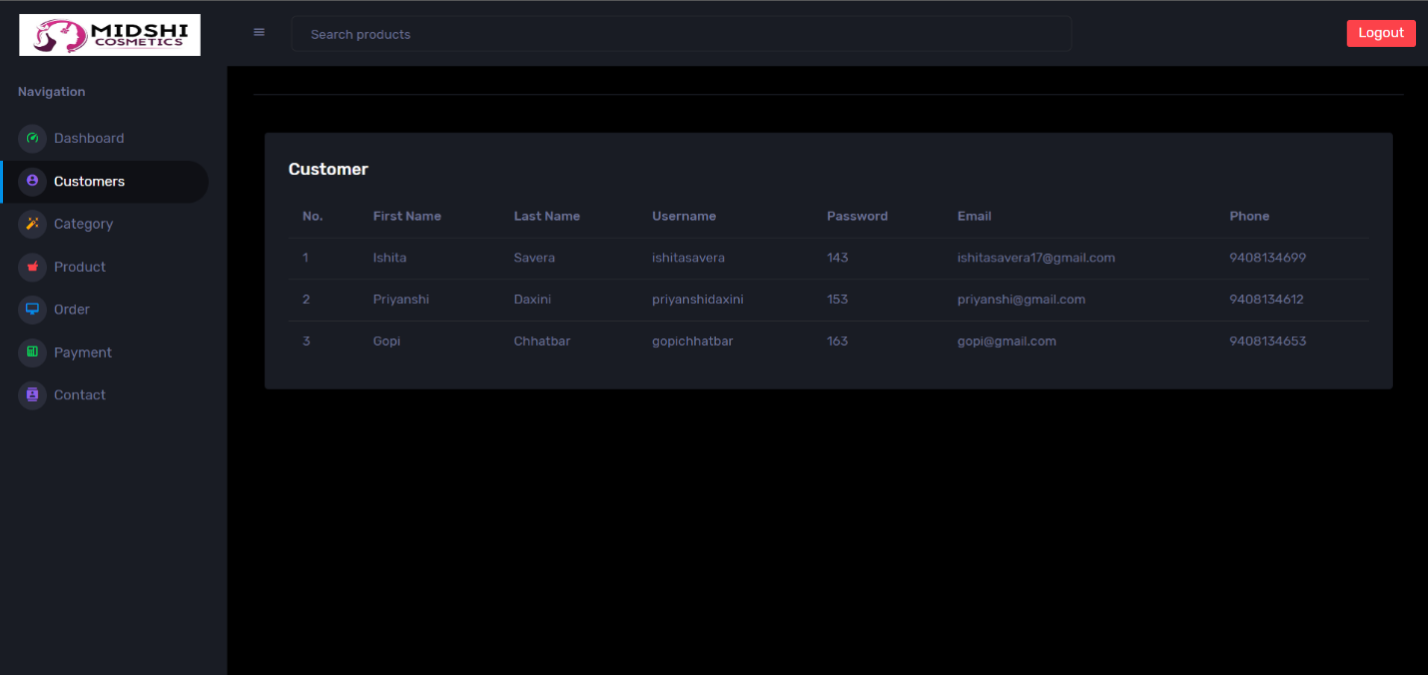

**Category Page:**

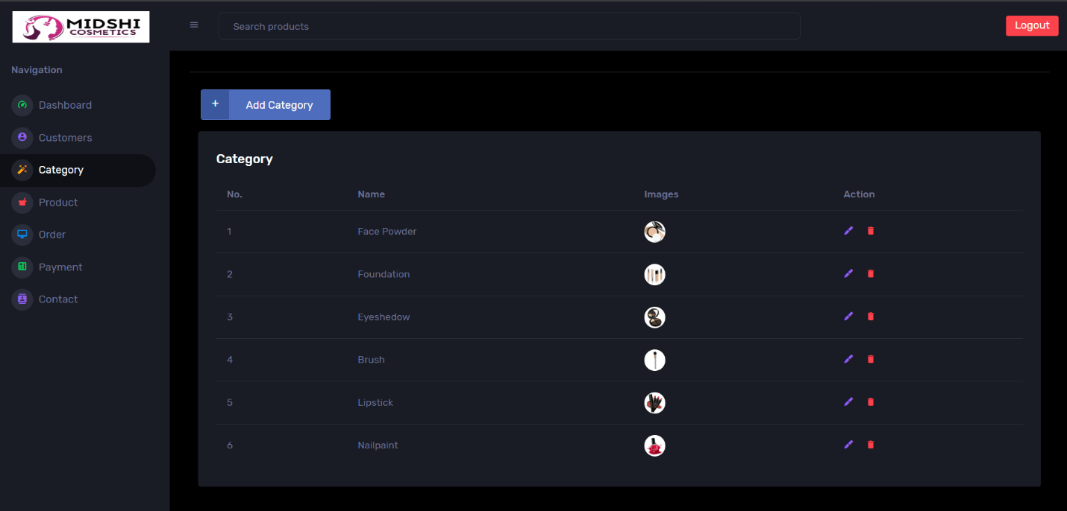

**Add Category Page:**

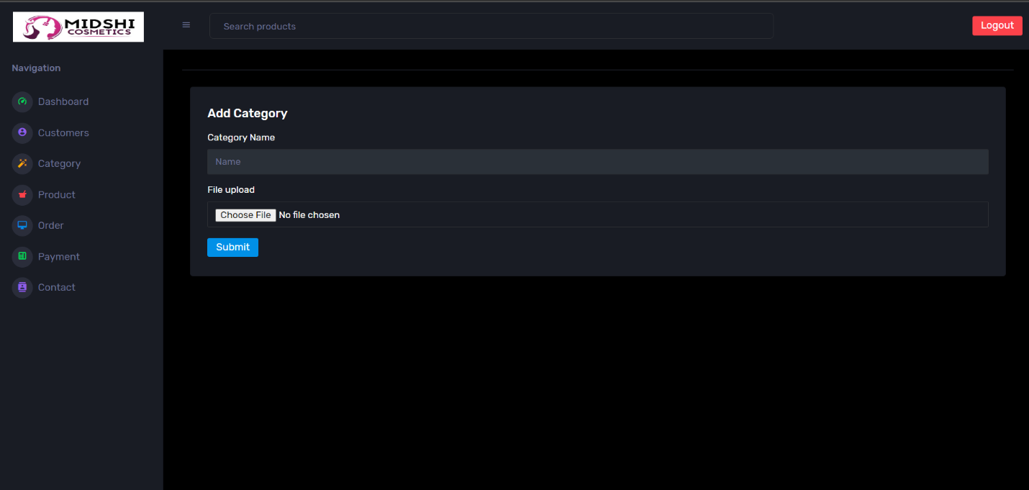

**Product Page:**

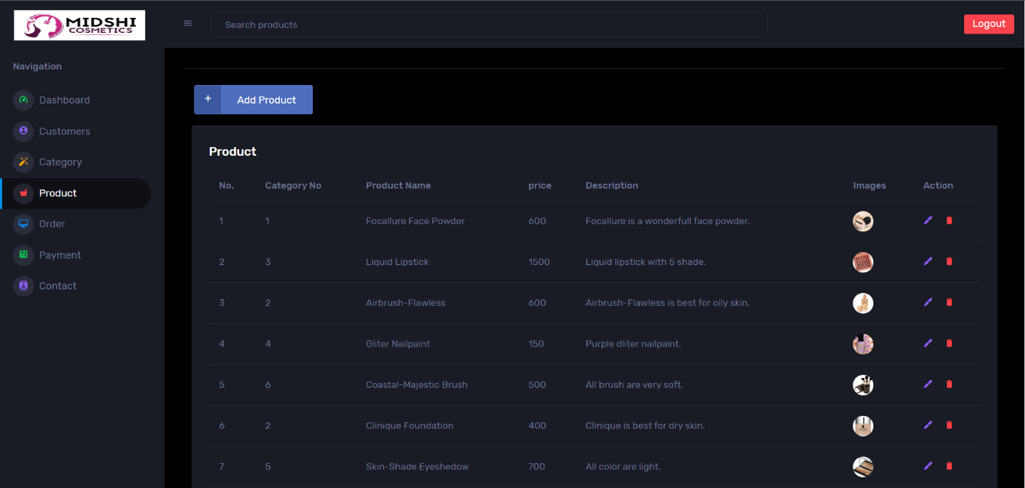

**Add Product Page:**

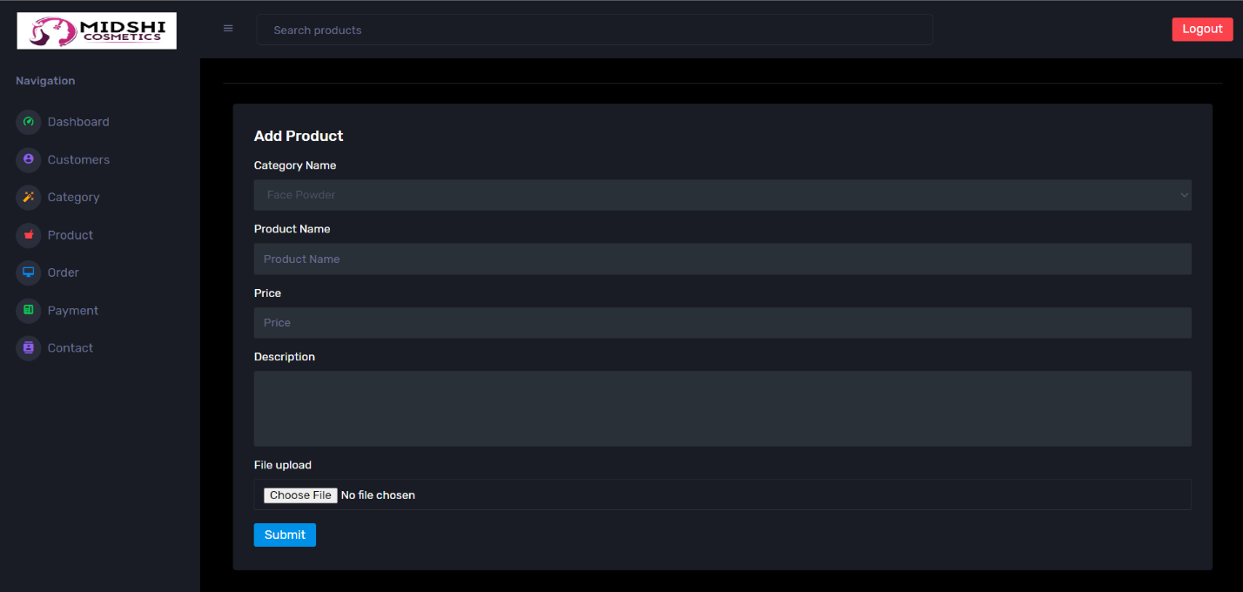

**Order Page:**

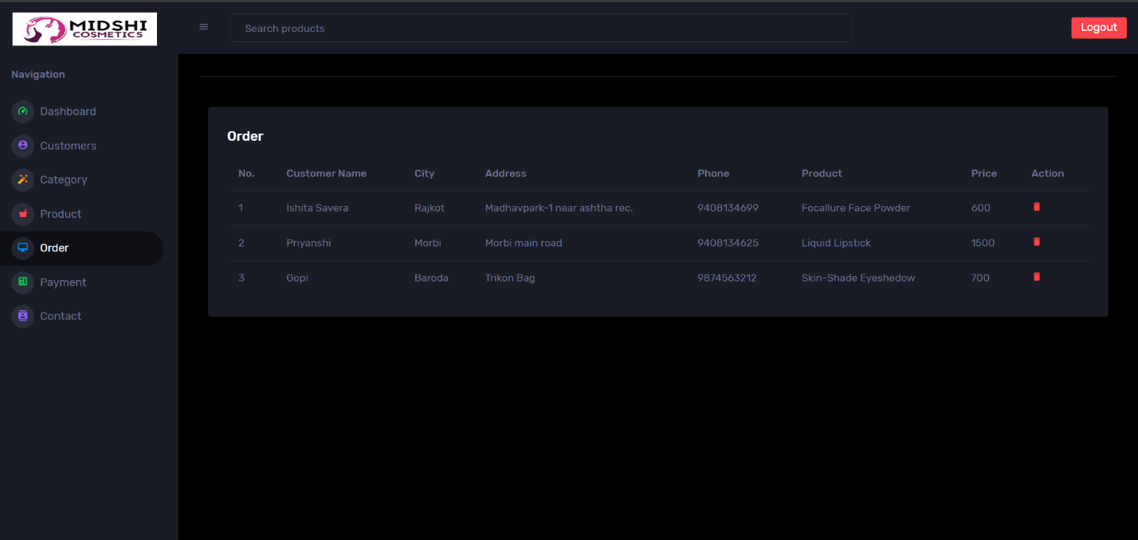

**Payment Page:**

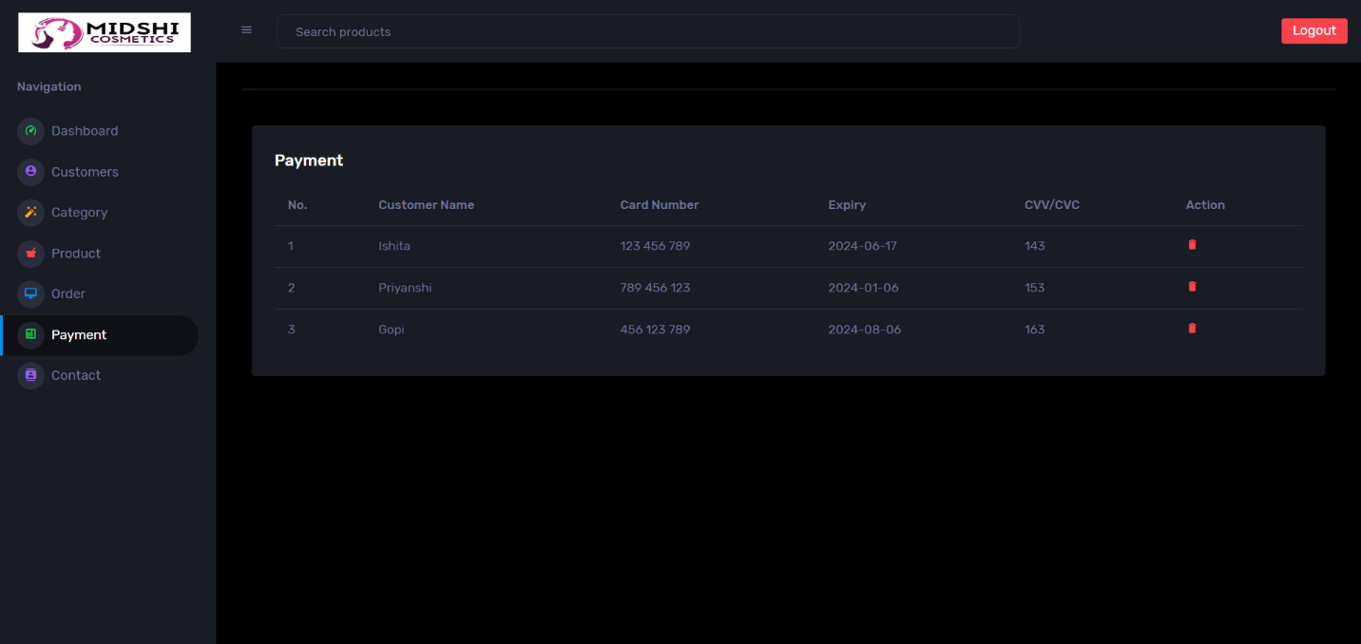

**Contact Page:**

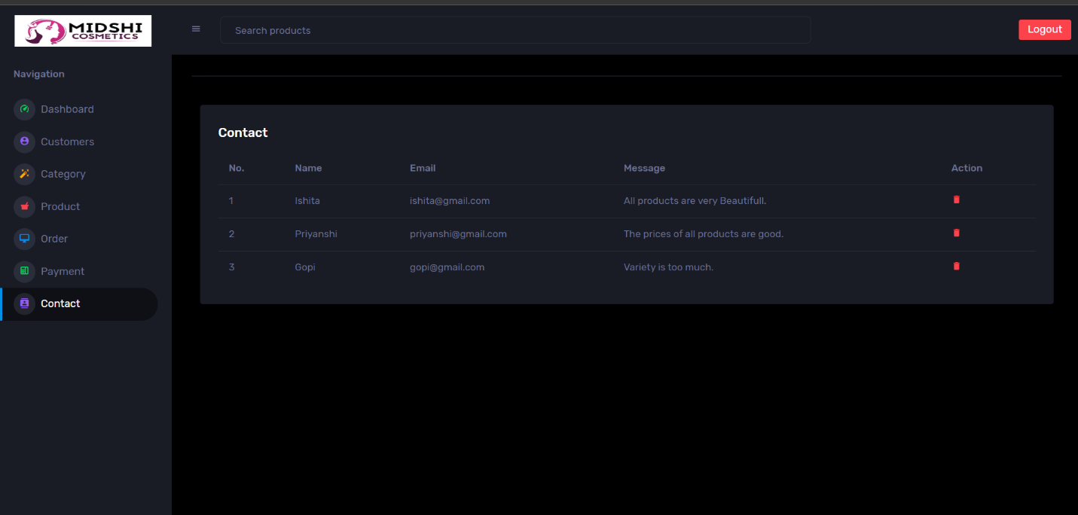

**Websites**

**XAMPP:** **http://www.apachefriends.org**

**PHP:** [**http://www.php.net**](http://www.php.net)

**MySQL:** **http://www.mysql.com**

**Client Templet Download:** [**https://www.free-css.com**](https://www.free-css.com)

**Admin Templet Download:** [**https://themewagon.com/themes/corona-free-responsive-bootstrap-4-admin-dashboard-template**](https://themewagon.com/themes/corona-free-responsive-bootstrap-4-admin-dashboard-template)

**Image Size:** [**https://www.img2go.com/result#j=41e0242a-2b33-4f73-a4b0-48543c34ec05**](https://www.img2go.com/result#j=41e0242a-2b33-4f73-a4b0-48543c34ec05)

**Suggestion**

**……………………………………………………………………………………………………………**

**……………………………………………………………………………………………………………**

**……………………………………………………………………………………………………………**

**……………………………………………………………………………………………………………**

**……………………………………………………………………………………………………………**

**……………………………………………………………………………………………………………**

**……………………………………………………………………………………………………………**

**……………………………………………………………………………………………………………**

**……………………………………………………………………………………………………………**

**……………………………………………………………………………………………………………**

**……………………………………………………………………………………………………………**

**……………………………………………………………………………………………………………**

**……………………………………………………………………………………………………………**

**……………………………………………………………………………………………………………**

**……………………………………………………………………………………………………………**

**……………………………………………………………………………………………………………**

**……………………………………………………………………………………………………………**

**……………………………………………………………………………………………………………**

**……………………………………………………………………………………………………………**

**……………………………………………………………………………………………………………**